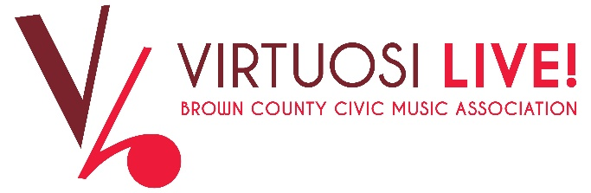

Nomination Form -- Board of Directors

Name: _______________________________________________________________________
Last M.I. First

Address: _____________________________________________________________________
No./Street City State Zip

Contact Information: Cell Phone: ___________________ Home: ________________________

E-Mail _____________________________________________________________________

1. Work and or Volunteer Experiences

2. Have you read the Board Responsibilities document? Yes_____

3. Do you understand the responsibilities and believe you can meet them? Yes_____

4. Statement of Interest: Why are you interested on serving on the BCCMA Board of Directors?

5. What do you hope to contribute as a BCCMA Board Member:

6. What education/skills could you contribute to board committees? Please check all that apply.

- Fundraising – Donations, grants, sponsorships, community contacts
- Marketing, Promotion, Media – social media, website
- Finance, Audit, Investments, Budgets
- Nominating (new board members)
- Concert Management – Sourcing volunteers
- Artistic Selection and Evaluation

Signature ____________________________________________________________________

Print Name ___________________________________________________________________

Date: __________________________________

Contacts for additional information:
Laura Fisher-Bonvallet, President - ljfisherbonvallet@gmail.com
Margaret Gonzales, Vice President - Mgsing41@aol.com
Sergio Heredia, Nominating - sherediamd@sbcglobal.new

